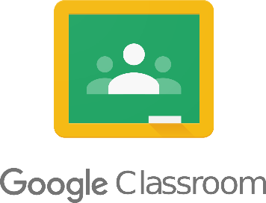
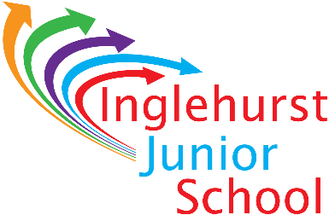

Parent/Guardian Updates
If you would like to receive updates via email with regards to your pupil’s assigned work, please return this slip with your details entered. You will receive an email asking you to accept the invitation to be a parent/guardian on your pupil’s Google Classroom, you can then choose how often you would like to be updated, and what you would like updates on.

Google Classroom Updates
Child:………………………………………..
Class:………………………………………..
I would like to receive updates via email on the following email address (please enter one letter/character per box):
Example:
P | S | M | I | T | H | @ | G | M | A | I | L | . | C | O | M

Your Email:

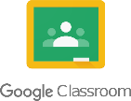
Signed……………………………………………………………………………………………………………………………………

