Google Classroom on a Phone or Tablet
Before you begin, you should download the Google Classroom app:
Install the Classroom app on Android
Your device must have Android 4.4 KitKat or later to get the latest version of the Classroom app.
- On your device, tap Play Store .
- Find and install the Google Classroom app.
Install the Classroom app on iPhone or iPad
Your device must have iOS 11 or later to get the latest version of the Classroom app.
- On your device, tap App Store .
- Find and install the Google Classroom app.

Accessing your Assignments
- Tap Classroom .
- Tap Get Started.
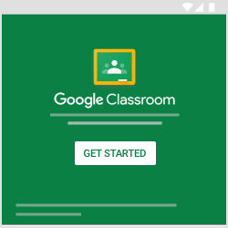
- Tap Add account, then OK.
- Enter the email address for your Classroom account and tap Next.
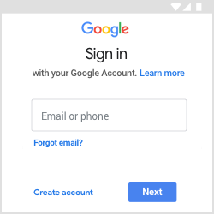

- Enter your password and tap Next.
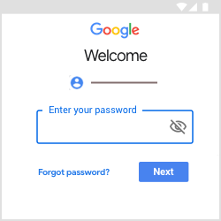
- If there is a welcome message, review it and tap Accept.
- Review the Terms of Service and Privacy Policy and tap I agree
- Tap on Classwork.
- You can now view your tasks/homework.

